

Department of Computer Science and Engineering

Course Code: CSE464

Course Title: Advance Database

Section: 02

Semester: Fall 24

**LAB-2 Assignment**

**Submitted to:**

**Khairum Islam**

Lecturer

Department of Computer Science and Engineering

East West University

**Submitted by:**

**Name:** B. M. Shahria Alam

**ID:** 2021-3-60-016

**Date of submission:** 23 November, 2024.

**1**

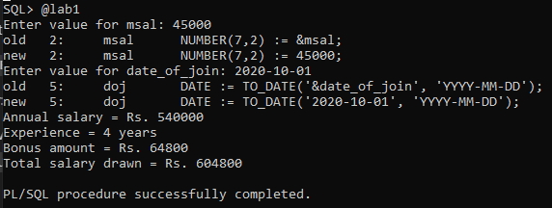

**2.**

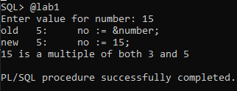

**3.**

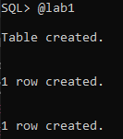

**4.**

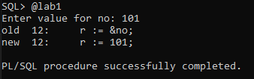

**5.**

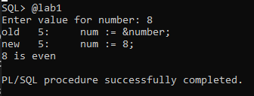

**6.**

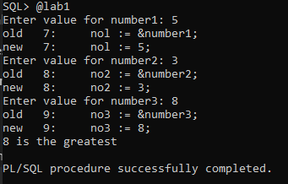

**7.**

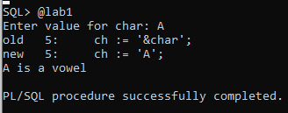

**8.**

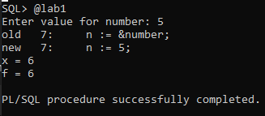

**EXERCISE 1:**

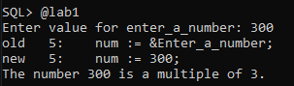

**EXERCISE 2:**

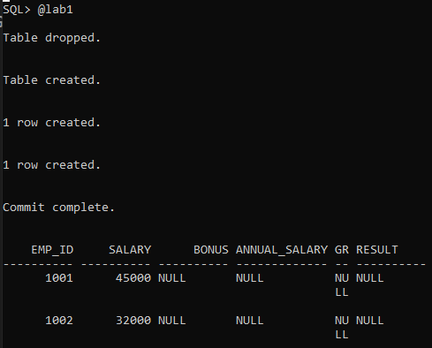

**EXERCISE 3:**

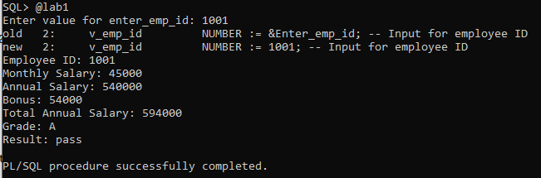

**EXERCISE 4:**

